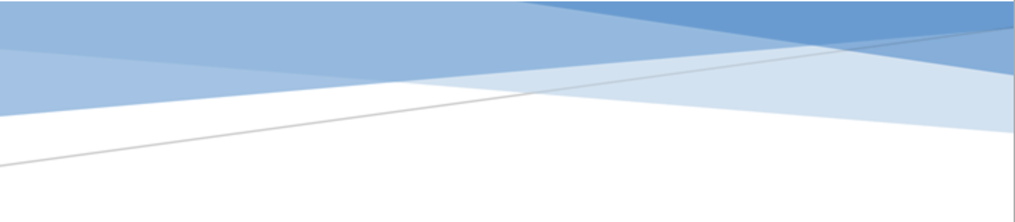



ADGES UI COMPONENTS LIBRARY

**Component ID #1 – ex-floating-action-button - v1.0.0**

## Document Control

## Version History

|  |  |  |  |
| --- | --- | --- | --- |
| Version | Date | Author | Reason for Change |
| 1.0.0 | 10/28/2020 | Ahmedalaaezzt |  |
|  |  |  |  |
|  |  |  |  |
|  |  |  |  |
|  |  |  |  |
|  |  |  |  |
|  |  |  |  |
|  |  |  |  |

## Review History

|  |  |  |
| --- | --- | --- |
| Version | Reviewer | Date |
|  |  |  |
|  |  |  |
|  |  |  |
|  |  |  |
|  |  |  |
|  |  |  |
|  |  |  |

Table of Contents

Document Control 1

Version History 1

Review History 1

1. Document and components Purpose. 3

2. General Information. 3

3. How to use. 3

4. Component features and configure. 4

5. How to configure component. 4

6. Examples 4

# 

# Document and components Purpose.

The purpose of the document is to guide how use and configure [Floating action button] component.

The purpose of the floating action button you can add a floating button that able to hold a URL to open a link and you can configure the component based on your branding guideline.

# General Information.

Component Name: Floating-action-button.

Extension Theme: ex-floating-action-button.

Owner: Ahmedalaaezzt.

Version no: v1.0.0

Design

Default



Hover

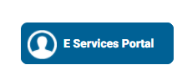

# How to use.

1. The available commands for this project .
   1. Compile : npm run gulp compile -- –path ex-floating-action-button –extension
   2. Compile & include under ADGE tenant : npm run gulp compile -- –path ex-floating-action-button –extension –full –dest [ADGEFolder]
   3. Deploy : npm run gulp deploy -- –path ex-floating-action-button –extension
2. *Now project have full copy from this extension theme under the project theme and you can apply the project brand guideline and configure component based on project needs.*

# Component features and configure.

You have access now to configure component with the below item.

|  |  |  |
| --- | --- | --- |
| Feature | Variable | Default value |
| floating-action-button | | |
|  | $floating-action-button-background-color | $ADGE-500 |
|  | $floating-action-button-background-color-hover | $ADGE-900 |
|  | $floating-action-button-top-corner-color | $ADGE-900 |
|  | $floating-action-button-width | 50px |
|  | $floating-action-button-height | 50px |
|  | $floating-action-button-border-radius | 8px |
|  | $floating-action-button-transition | width 0.2s ease |
|  | $floating-action-button-z-index | 9 |
| Location | | |
|  | $floating-action-button-start-space | 5px |
|  | $floating-action-button-top | calc(50% - 25px) |
| Label | | |
|  | $floating-action-button-label-color | $white-color |
|  | $floating-action-button-label-font-size | 14px |
|  | $floating-action-button-label-line-height | 22px |
|  | $floating-action-button-label-padding | 14px 0 |
|  | $floating-action-button-label-margin | 4px 0 0 0 |
| extended in hover | | |
|  | $floating-action-button-rtl-extended-width | 183px |
|  | $floating-action-button-ltr-extended-width | 183px |
| container  Inside the button we have container that hold the icon and label | | |
|  | $floating-action-button-elements-container-height | 107% |
|  | $floating-action-button-elements-container-corner-border-radius | 29px |
|  | $floating-action-button-elements-container-top | -3px |
| image | | |
|  | $floating-action-button-img-width | 35px |
|  | $floating-action-button-img-height | 35px |
|  | $floating-action-button-img-margin | 12px 8px 8px 8px |

# How to configure component.

You need to copy all variable that’s you need to change from file _variables.scss under vars folder under the extension theme component, then past the copy variables in file _custom.scss under vars folder under the project theme folder.

# Examples

Examples1:

I need to change text color.

I’ll copy the below variables from extension theme.

$highlight-main-tittle-color: $primary-color;

Then will paste the above variable in project folder theme in file _custom.scss and change with any variable based on site needs.

$highlight-main-tittle-color: $secondary-color;

Examples2:

I need to the button shape from square to had a rounded corner.  
I’ll copy the below variables from extension theme.

$button-shape-square: $border-radius-value;

$border-radius-value: 0px;

Then will paste the a above variable in project folder theme in file _custom.scss and change with any variable based on site needs.

$button-shape-square: $border-radius-value;

$border-radius-value: 20px;